Epidemiology of Rhinitis – Brief review
Bryant Lin, MD
Arrinex Inc.

Introduction
Rhinitis, inflammation of the nasal mucosa, is a common disorder arising from environmental allergies (e.g. hay fever) and non-allergic causes such as vasomotor dysfunction. The current epidemiologic studies have examined its prevalence utilizing surveys querying patient’s symptoms and prior diagnoses as well as using medical cost databases. The goal of this short paper is to provide an overview of the epidemiology of rhinitis. The vast majority of studies have looked at prevalence of allergic rhinitis whereas the prevalence of non-allergic rhinitis is less well defined.

Allergic Rhinitis
Diagnosed Patients
The CDC in its National Health Interview Survey, most recently using data from 2012, reported 17.6 million adults and 6.6 million children who responded that they were told by a doctor or other health professional that they had “Hay Fever” within the past 12 months ^{1, 2}.

Data from the Medical Expenditure Panel Survey (MEPS) was first studied by Law et al using data from 1996 ³. MEPS is a “nationally representative survey of health care use and spending in the civilian, noninstitutionalized population of the United States” administered by the US government. About 7.7% of the US population (20.9 million) were reported to have a diagnosis of allergic rhinitis. About 13.3 million of those patients sought medical treatment (through a visit with a medical provider or receiving a prescription drug). Fifty-eight percent of people with allergic rhinitis received one or more prescription drugs as treatment (average 3 prescriptions filled per year)³.

Data from the MEPS in 2005 was studied by Reardon et al⁴. They found that prevalence of allergic rhinitis rose to 26.7 million (9.0% of the US population). Treatment rates increased as well as 81% of patients sought some sort of treatment up from 66% in 1996.

Symptom Surveys
Another method to assess the prevalence of rhinitis is through symptom surveys. These prevalence studies have reported 20 to 79 million US allergic rhinitis sufferers ^{1,2,3,5,11}. We believe the prevalence data presented from MEPS and the CDC have the most utility in quantifying patients who are amenable for orthodox medical treatment as opposed to those who have symptoms but may or may not seek medical care. However, these symptom surveys are useful in characterizing frequency of specific symptoms and the distribution of severity of disease in these patients.

One of the largest, most recent studies was characterizing symptom was the “Burden of Rhinitis in America Survey” run and published by Derebery et al⁶. A screening questionnaire was sent to a representative sample of 15,000 households with 9822 individual receiving follow up questionnaires half who screened positive and half who screened negative for rhinitis symptoms > 7 days in the past 12 months. The rhinitis sufferers in the follow up questionnaire were then defined as having rhinitis symptoms within the past 4 weeks. Over fourteen percent (557/3831) of rhinitis sufferers had severe symptoms. Runny nose, post nasal drainage and congestion were the most common symptoms (Table 4)⁶. About 17.4% of people reported their nose symptoms were not controlled within the past 4 weeks (unchanged or worse, Table 5)⁶.

Allergic versus Nonallergic
The breakdown between allergic and nonallergic rhinitis has been assessed in a variety of studies. Settipane et al published an excellent review of those studies revealing 71% allergic versus 29% nonallergic rhinitis distribution on average between the studies (Table 3)⁷.

Persistent versus Intermittent (Allergic)
The allergic rhinitis and its impact on asthma workgroup (ARIA) devised a new classification for allergic rhinitis – intermittent and persistent – which differs from the classical seasonal/perennial classification. This new system has become widely accepted as it depends on frequency of symptoms solely as opposed to seasonality. In a large study by Bauchau, 29% of AR patients had persistent symptoms (occurring for more than 4 days/week and more than 4 consecutive weeks)⁸.

Nonallergic Vasomotor
The prevalence of nonallergic rhinitis is more challenging to study as it remains a clinical diagnosis with no “gold standard” test analogous to skin allergen testing for allergic rhinitis. Frequently, studies have used the absence of a positive skin test to indicate a nonallergic cause of symptoms. The challenge with this method is that it results in patients with mixed allergic and nonallergic rhinitis to be classified with those with pure allergic rhinitis. Clinically, the diagnosis of vasomotor rhinitis is based primarily on the assessment of the characteristics of a patient’s symptoms. Due to the higher prevalence of allergic rhinitis, there tends to be an initial presumption that all patients with rhinitis have the disorder because of environmental allergies. The breakdown of vasomotor versus non-vasomotor cause for nonallergic rhinitis was discussed in the same Settipane paper⁷. Three studies were identified with a weighted 71% of nonallergic rhinitis patients having vasomotor symptoms (Table 5)⁷.

Treatment Failures
Allergic Rhinitis
Nasal steroids are the first line treatment for allergic rhinitis. They are effective but not all patients benefit. A recent review covering newer nasal steroids by Lumry reported success rates from various studies from 60 to 80%⁹. A typical result shown in figure 2 depicts Nasonex (MFNS) and Flonase (fluticasone) only having complete or marked relief in 69% and 60% of patients respectively thus implying that 31 to 40% of patients had incomplete or no relief⁹.

Vasomotor Rhinitis
There are limited treatments for vasomotor rhinitis. The mainstay long-term pharmacological treatment has been nasal Atrovent (ipratropium bromide) which has had low compliance as it requires use three to four time a day. Bronsky et al compared Atrovent versus placebo and found only about 70% had good or excellent response to treatment implying 30% had moderate or poor response(Figure 2)¹⁰.
Conclusion
From the CDC, 17.6 million adults were given a diagnosis of allergic rhinitis within the past 12 months. A novel procedure based therapy could target all of these patients but those patients with more frequent symptoms (such as those with persistent AR, 29%) and those who are treatment failures (estimated at >20% from the nasal steroid studies) would most likely to be interested in a new treatment modality. Using these assumptions, this results in a market of over 1 million allergic rhinitis patients for a new treatment.

Assuming an approximate ratio of 29% of nonallergic relative to 71% allergic patients (17.6 million) as discussed above, this results in an estimated 7.2 million nonallergic US adults. If 71% of those patients are treatable vasomotor rhinitis patients (from Settipane’s estimate that 71% of nonallergic patients have vasomotor rhinitis) and 30% of those are treatment failures, we estimate 1.5 million vasomotor patients who are a likely target market for a new treatment.

Conservatively, over 2.5 million adults in America have frequent rhinitis symptoms and are treatment failures who could be amenable to a new treatment for rhinitis (figure below).

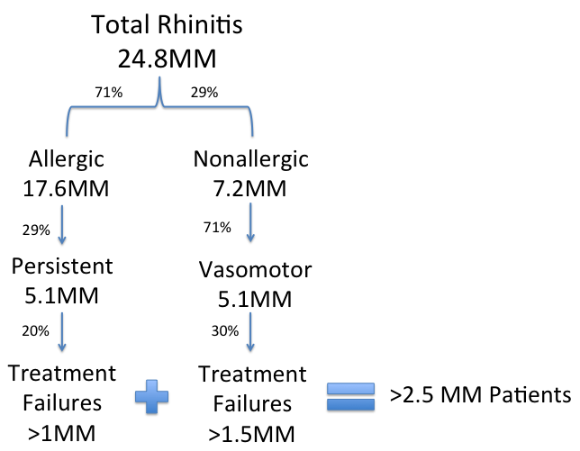

References

- Blackwell DL, Lucas JW, Clarke TC. Summary health statistics for U.S. adults: National Health Interview Survey, 2012. National Center for Health Statistics. Vital Health Stat 10(260). 2014.
- Bloom B, Jones LI, Freeman G. Summary health statistics for U.S. children: National Health Interview Survey, 2012. National Center for Health Statistics. Vital Health Stat 10(258). 2013.
- Law, Amy W., et al. "Direct costs of allergic rhinitis in the United States: estimates from the 1996 Medical Expenditure Panel Survey." Journal of allergy and clinical immunology 111.2 (2003): 296-300.
- Reardon, G., P. Navaratnam, and H. Leonard. "Prevalence and costs of allergic rhinitis in the United States: a comparison of 2005 and 1996 estimates from the Medical Expenditure Panel Survey." Journal of Allergy and Clinical Immunology 123.2 (2009): S271.
- Nathan, Robert A., et al. "Prevalence of allergic rhinitis in the United States." Journal of allergy and clinical immunology 99.6 (1997): S808-S814.
- Derebery, Jennifer, et al. "Rhinitis symptoms and comorbidities in the United States: Burden of rhinitis in America survey." Otolaryngology-Head and Neck Surgery 139.2 (2008): 198-205.
- Settipane, Russell A. "Epidemiology of vasomotor rhinitis." The World Allergy Organization Journal 2.6 (2009): 115.
- Bauchau, V., and S. R. Durham. "Epidemiological characterization of the intermittent and persistent types of allergic rhinitis." Allergy 60.3 (2005): 350-353.
- Lumry, William R. "A review of the preclinical and clinical data of newer intranasal steroids used in the treatment of allergic rhinitis." Journal of allergy and clinical immunology 104.4 (1999): s150-s159.
- Bronsky, Edwin A., et al. "A clinical trial of ipratropium bromide nasal spray in patients with perennial nonallergic rhinitis." Journal of allergy and clinical immunology 95.5 (1995): 1117-1122.
- Skoner, David P. "Allergic rhinitis: definition, epidemiology, pathophysiology, detection, and diagnosis." Journal of Allergy and Clinical Immunology 108.1 (2001): S2-S8.

